Initiating an Electronic Request for Personnel Action (RPA)

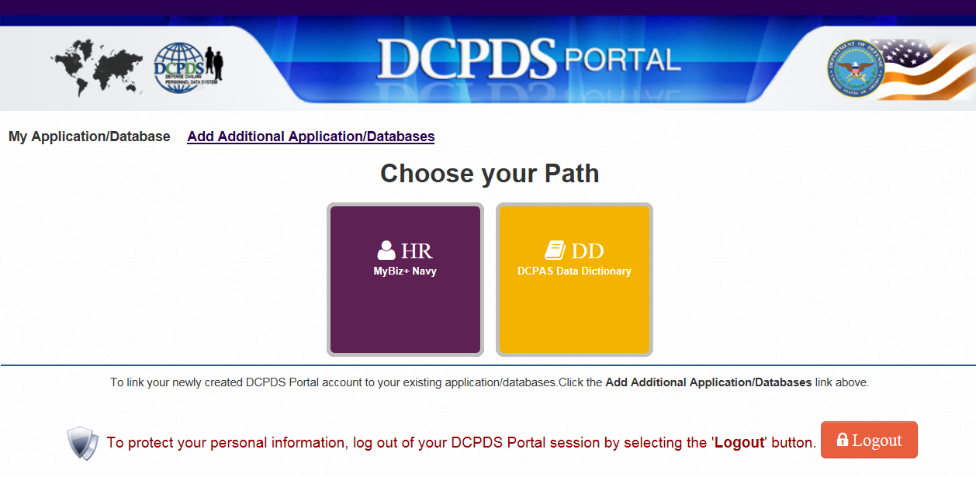

- NOTEPAD CONTENTS AND DOCUMENTS PREPARATION PRIOR TO INITIATING RPA

Please complete notepad contents and required documents referring to the sample document “RPA – List of Required Information and Documents” prior to initiating a Request for Personnel Action.

Page 1 – Position Revie RPA
Page 2 and 3 – Recruit/Fill RPA

Enclosure (1)

LIST OF REQUIRED INFORMATION AND DOCUMENTS

NOA - Recruit/Fill

*Document required on RPA for a Recruit/Fill Request:

Classification required documents:
-Summary sheet for “Position Designation of National Security and Public Trust Positions”
-Certification of Position Description
-Current Position Description

Staffing required documents:
-DoN Recruit/Fill Request Form (for position GS-09 and above)
-Crediting Plan (for position GS-08 and below)
-Certificate of Medical Examination (OF-178) – if position requires a pre-employment physical
-DON Civilian Acquisition Assignment Coding Sheet (DON DAWIA Operating Guide – Appendix H) – if applicable

*Notepad Information required on RPA notepad for a Recruit/Fill request:

Selecting Official: Name, email address, and phone number
Position Hierarchy information
1st level supervisor: Name, email address, phone number, BIC, position title (Pay Plan-Series-Grade, and position description number if civilian supervisor)
PH: First Name Last Name, PD#/Sequence# (i.e. PH: Joe Schmuckatelli, 12345A/876345)
2nd level supervisor: Name, email address, phone number, BIC, position title (Pay Plan-Series-Grade, and position description number if civilian supervisor)

Nature of action: Recruit/Fill
Vice: ###############
Vacant Since/Expected Vacancy Date: ##/##/####
BIC: M674000####
Position Title: ###################
Pay Plan-Series-Grade: GS-####-##
Position description (PD) number: ####
PEN: #####
BEA: ##
BESA: ##
UIC: 67400
DCPDS Organization Code (Table 30): ###
BUS CODE (Bargaining Unit Status): ####
GEO Local Duty Station Code: JA1065000
Camp: Camp Foster
Cost Center Code: ######
FIP: ###### ## ## ## #### ####
Funding Type: Direct

This remark is required if Recruit/Fill RPA is for an overseas tour extension request.
Advance recruitment for Mr./Mrs. ###### overseas tour extension. His/Her overseas tour expires on 1/30/2014.

This remark is required for positions GS-10 and higher.
Overseas allowances may be authorized in accordance with Department of State Standardized Regulation (DSSR), DoDI 1400.25, and applicable Department of the Navy policies.
Relocation cost and LQA may be authorized.

This remark is for positions GS-9 and below.
Overseas allowances (except for post allowance) is not authorized.
Sufficient funding is available to support this RPA.
Fund manager: Name & date
Once all the information (notepad contents and documents) are ready, access DCPDS website:
https://compo.dcpds.cpms.osd.mil/

Click <OK>
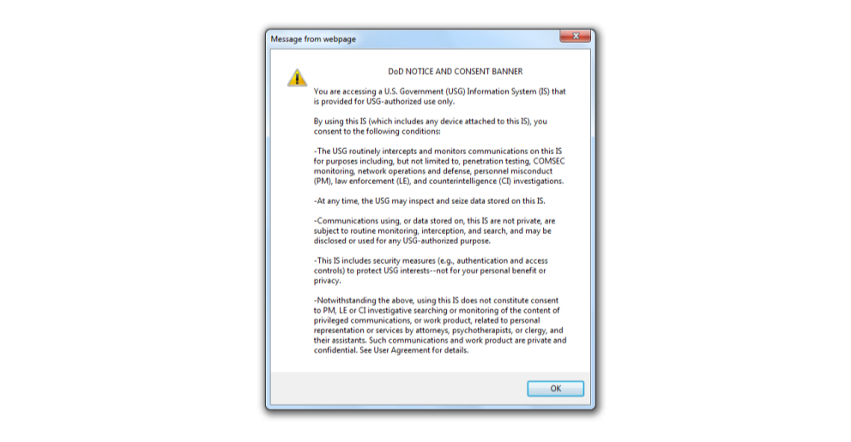
Click <Smart Card Login>
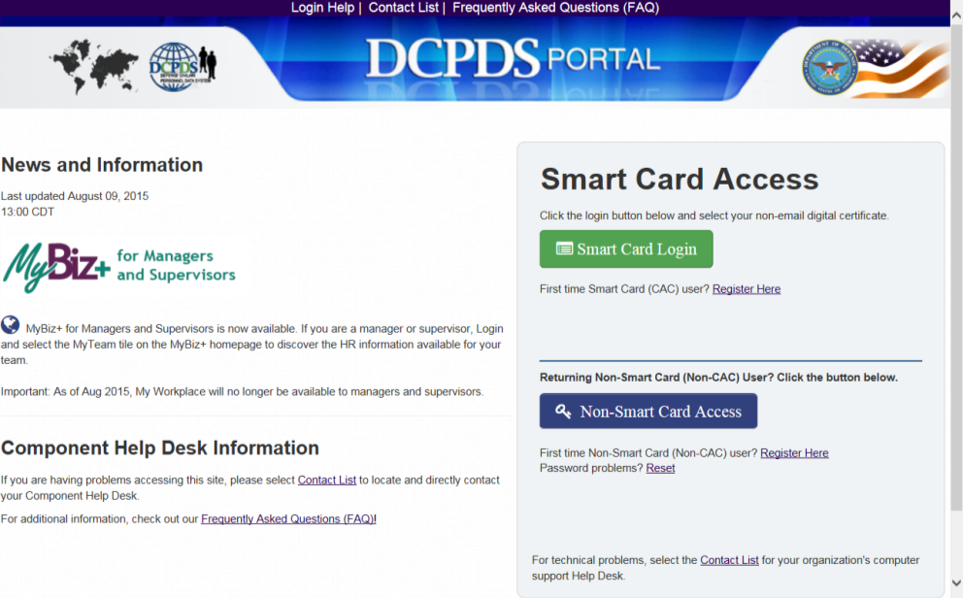

Note: If you have not completed CAC registration, please register yourself referring to this instructions manual.

If you’ve already registered yourself and having trouble when you log in, please clear your browser history referring to this instruction.

Select <Non-email certificate> and click <OK>
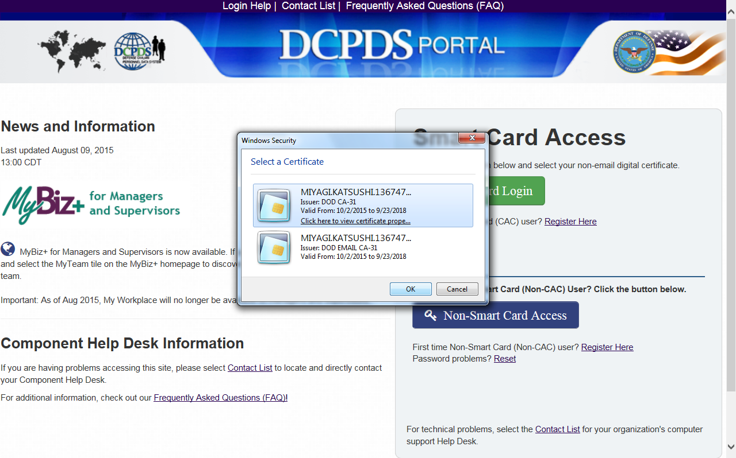

Click <HR>
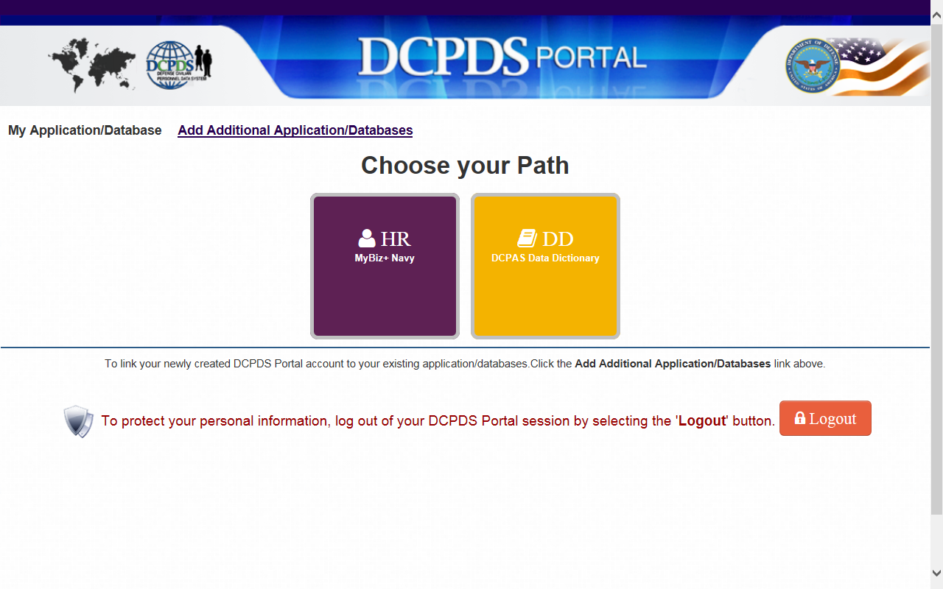
Click <Accept>
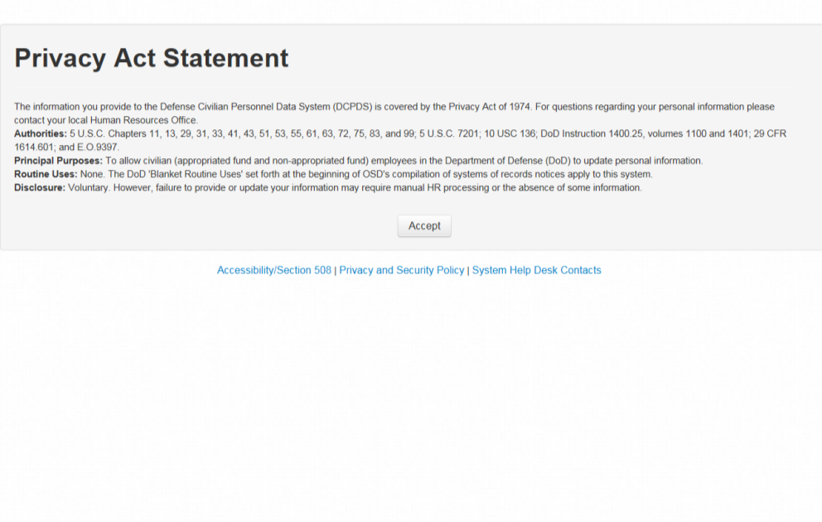

Select the responsibility (e.g., 67400 for employees who falls under UIC 67400)
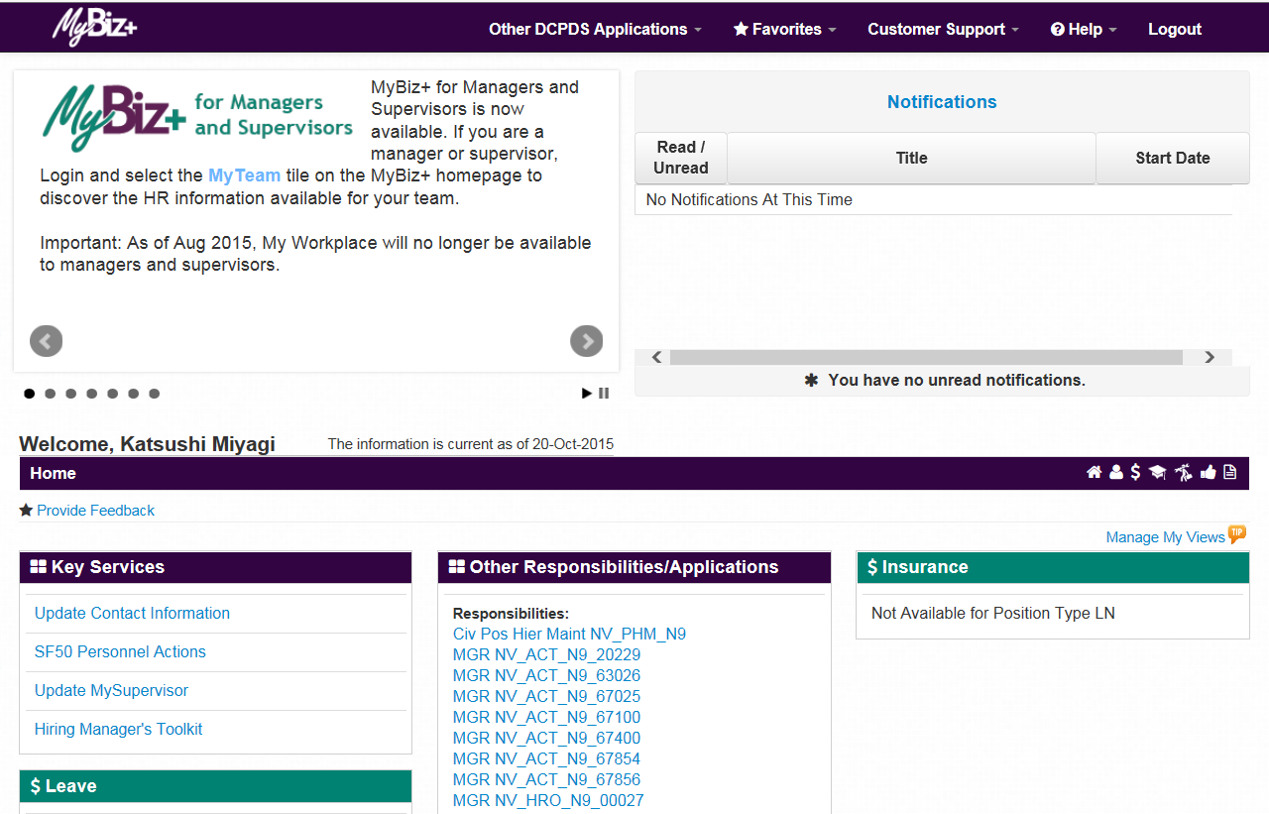
Scroll down and find <Request for Personnel Actions> and select <Recruit/Fill> (or any of the other type of actions listed under the Request for Personnel Action menu)”
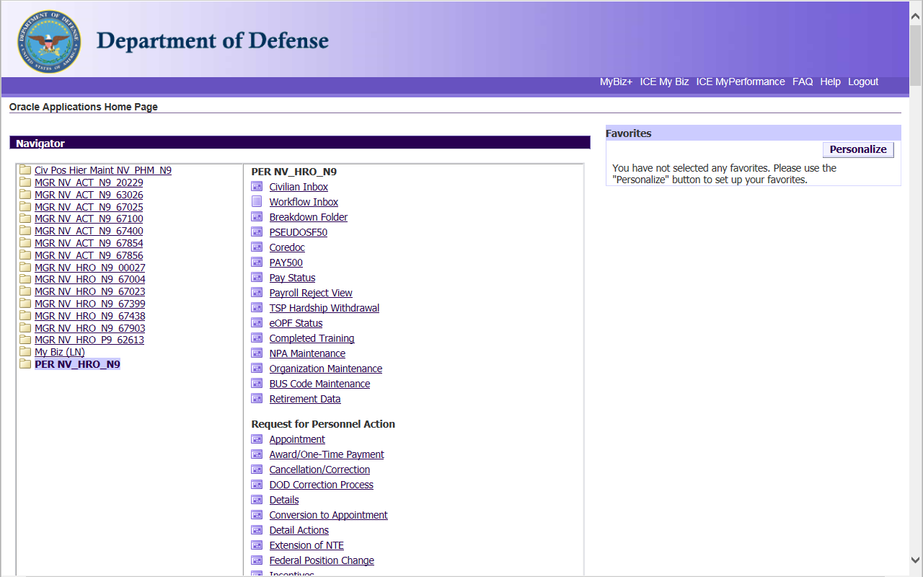

Click <Recruit/Fill>
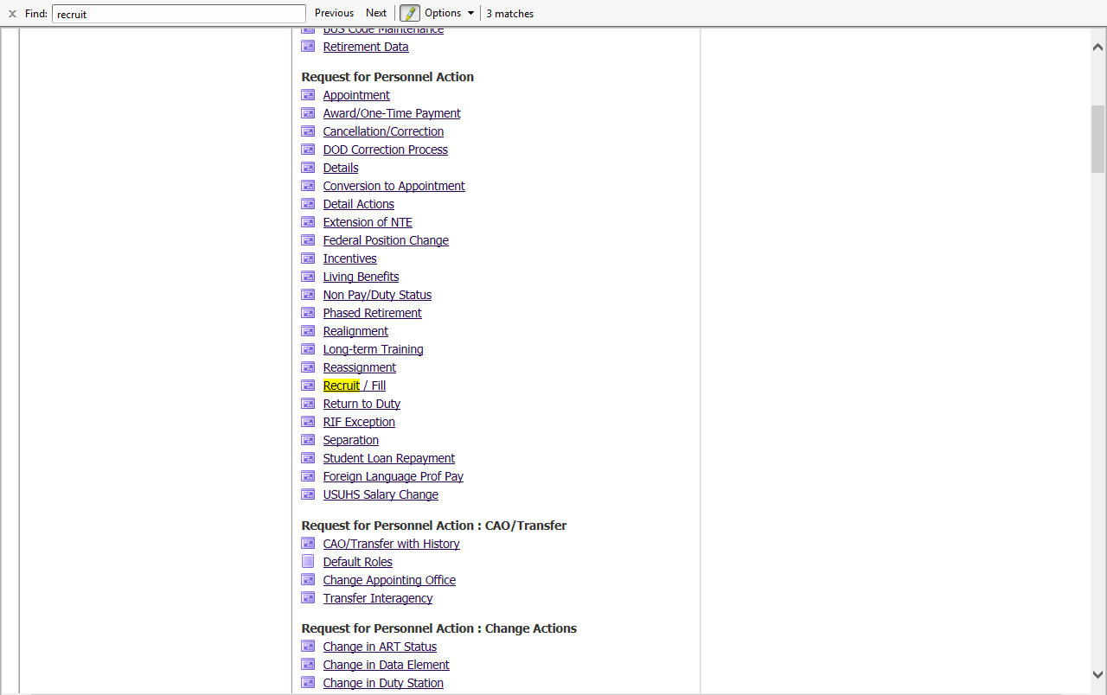
Wait for few minutes till Java applet starts then another window appears. <Leave this window open>
(Note: If the applet does not start after several minutes of waiting, contact 117 to check whether Java is properly installed. This problem often occurs after a routine push of updated software)
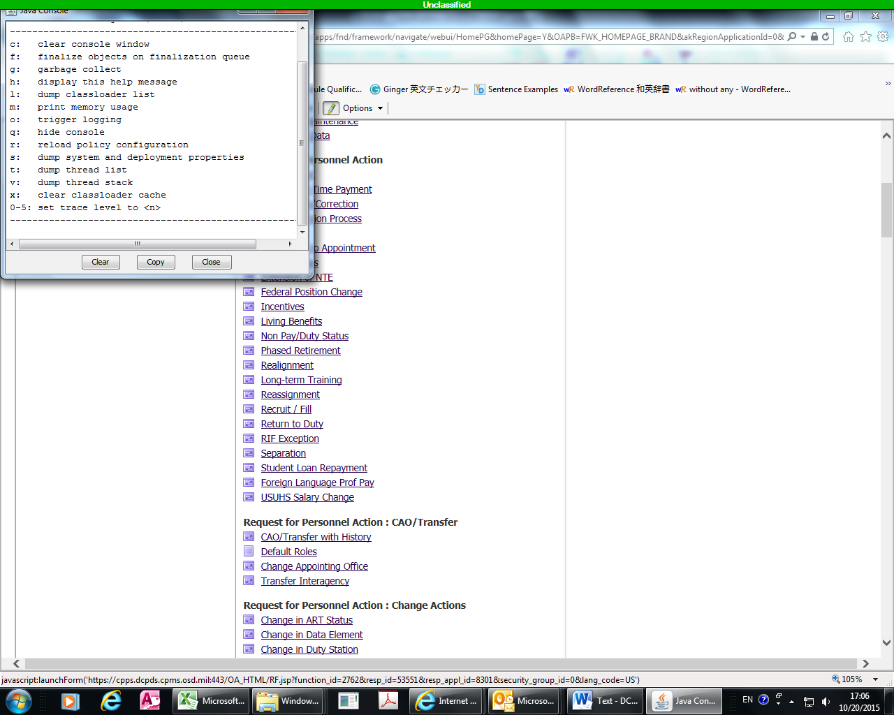

Click <Continue>
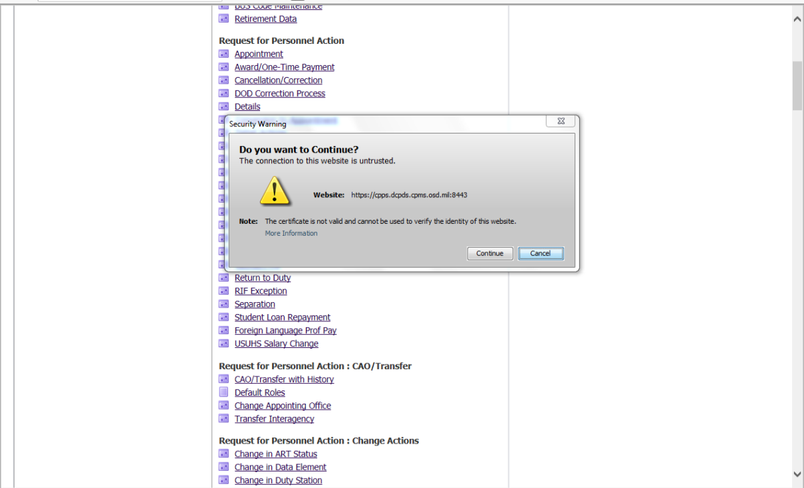
Java applet keeps running and wait for a new window to appear on screen
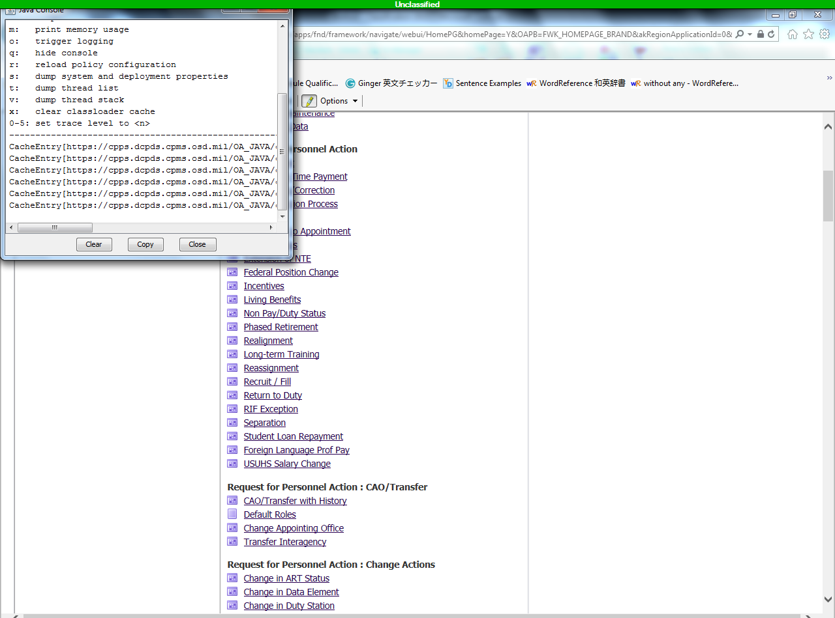

Oracle Application starts (Application is still running)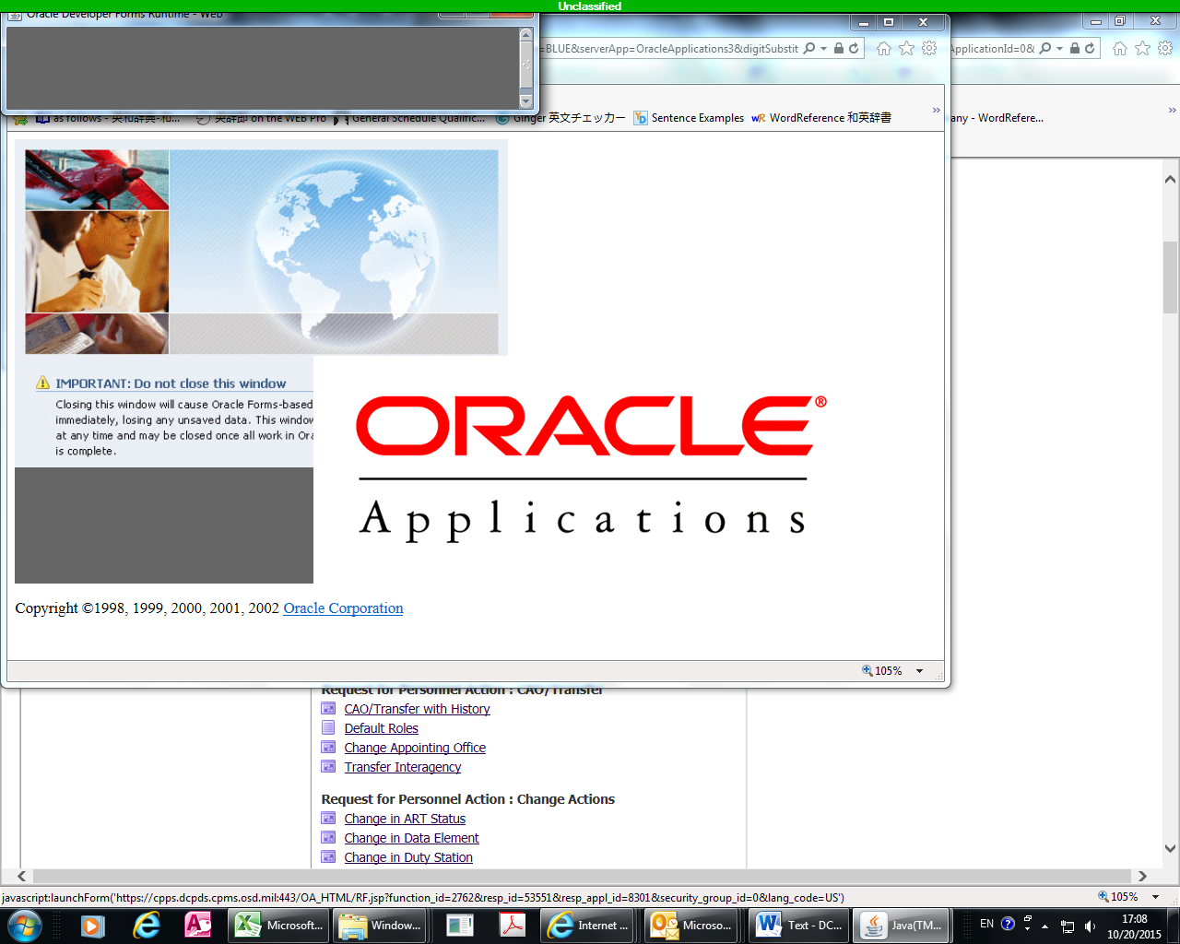
Request for Personnel Action Windows
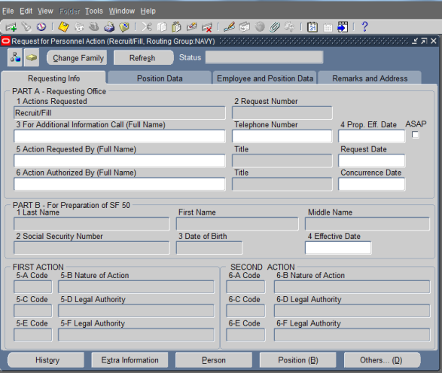
Type the last name of RPA initiator and hit <Enter>
Type the last name of RPA requestor and hit <Enter> . If the requestor does not have DCPDS account, leave this data field blank.

Click Notepad
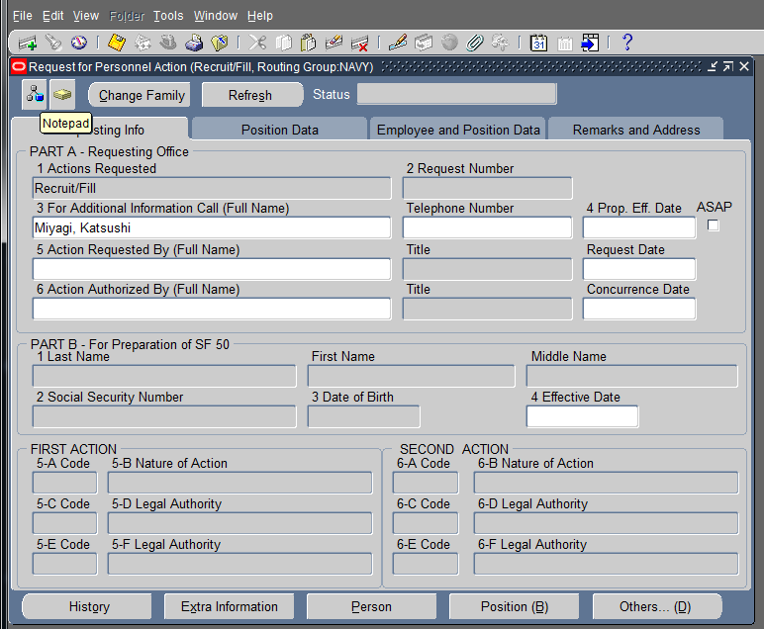
Click <New>
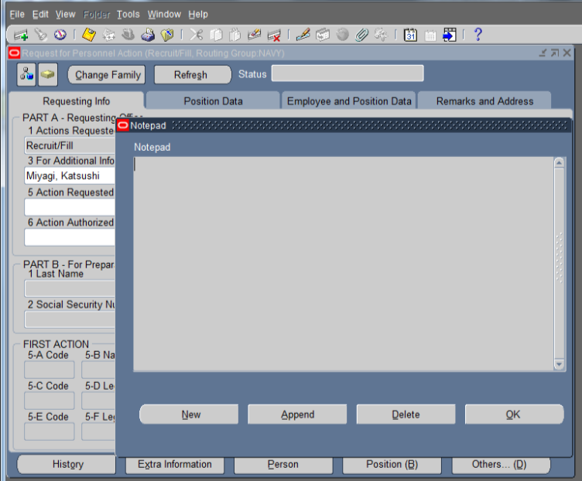

Paste notepad contents (which was prepared prior to creating RPA) and click <OK>.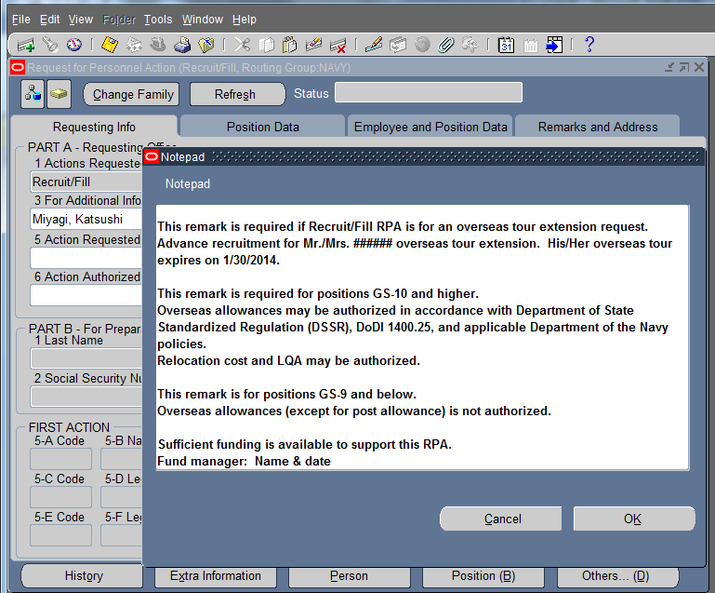
Click Attachment
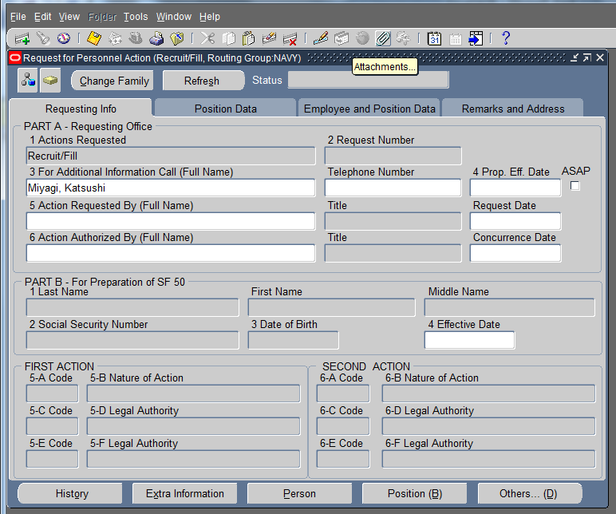

Click Yes
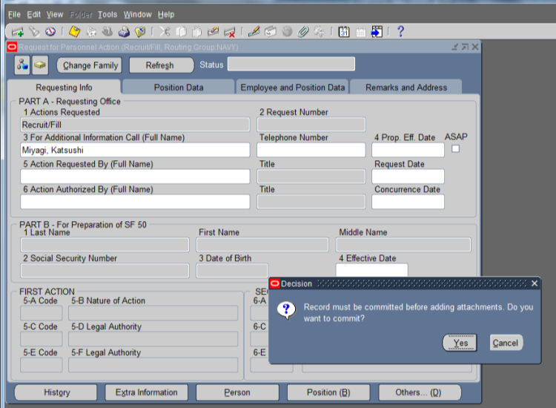
Click <No>
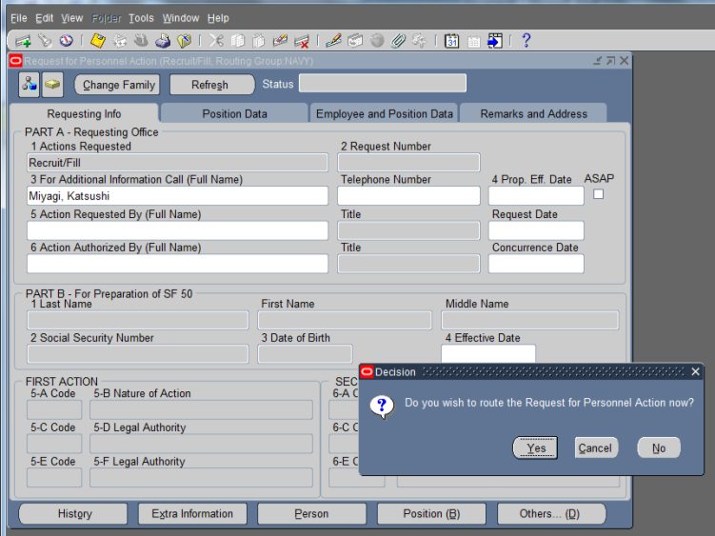

Take note of RPA number (last 6 digits) and click <OK>
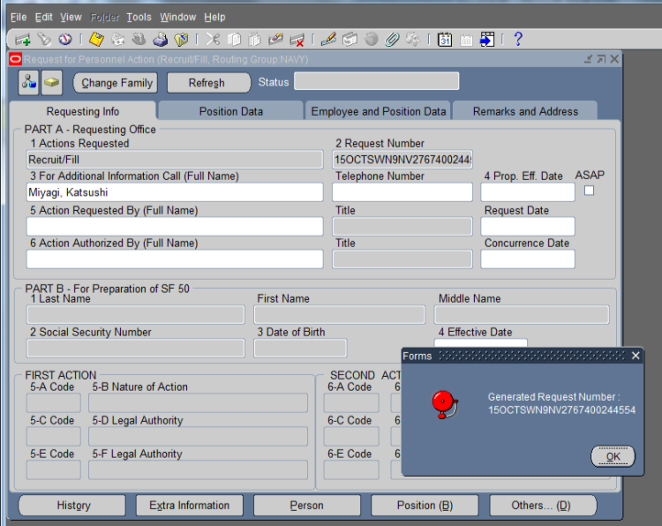
Click <OK>
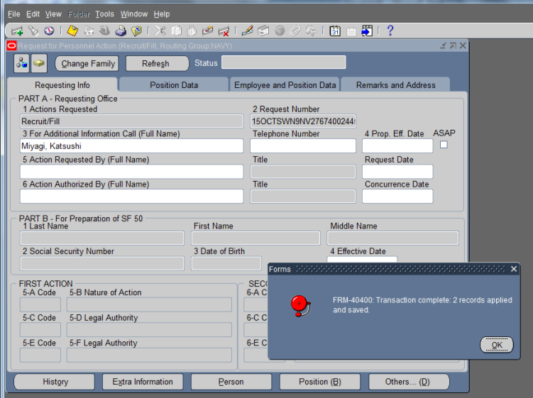

Type “misc” and hit <tab key>
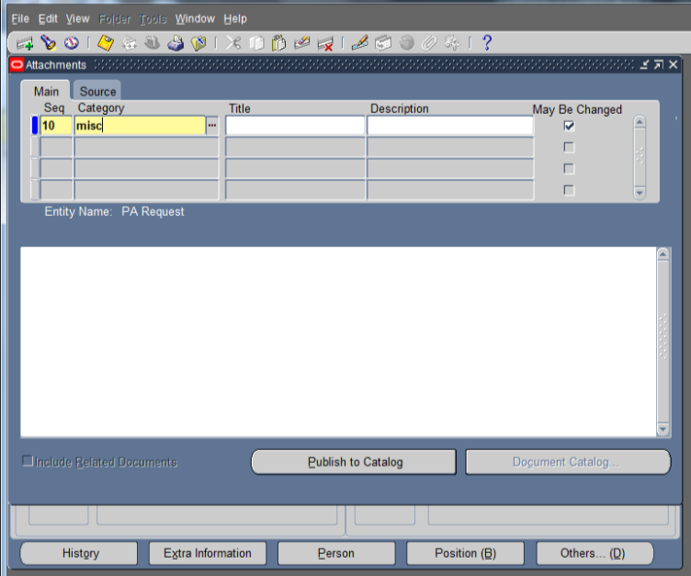
Type file name and file description (e.g. PD certification, Current PD, Org Chart, etc.)
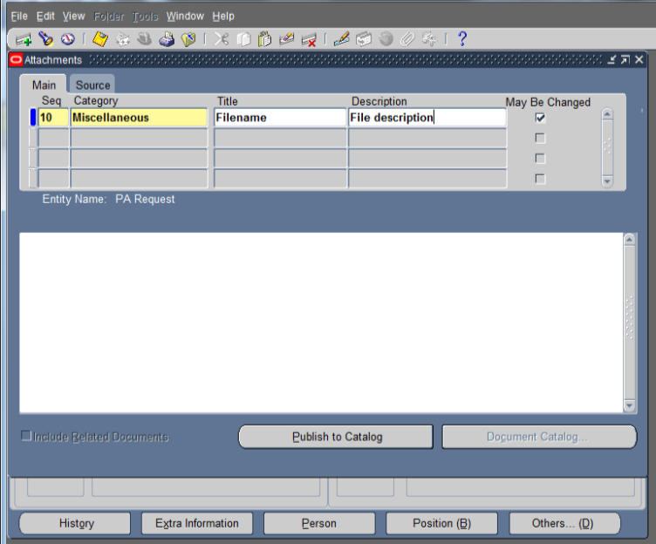

Select <File> and click <OK>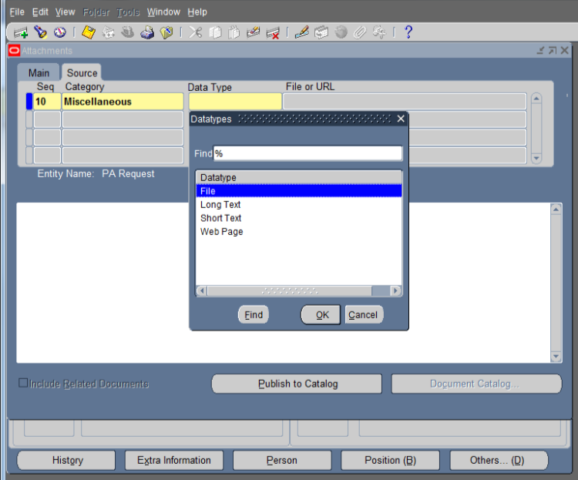
Click <Browse>
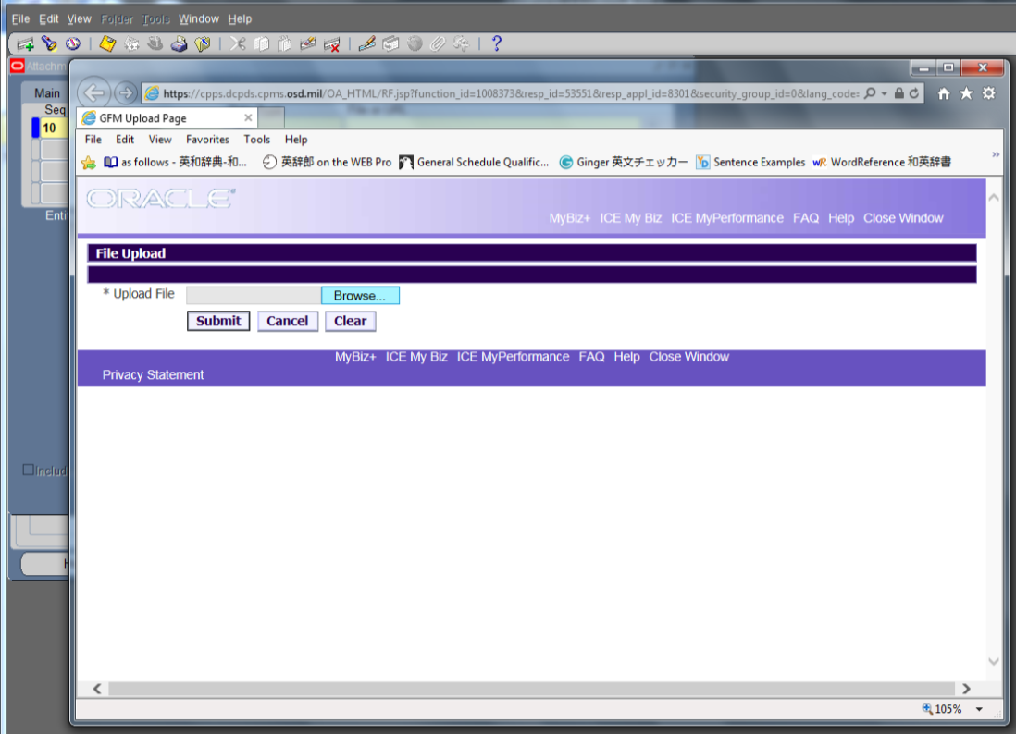

Select file and click <Open>
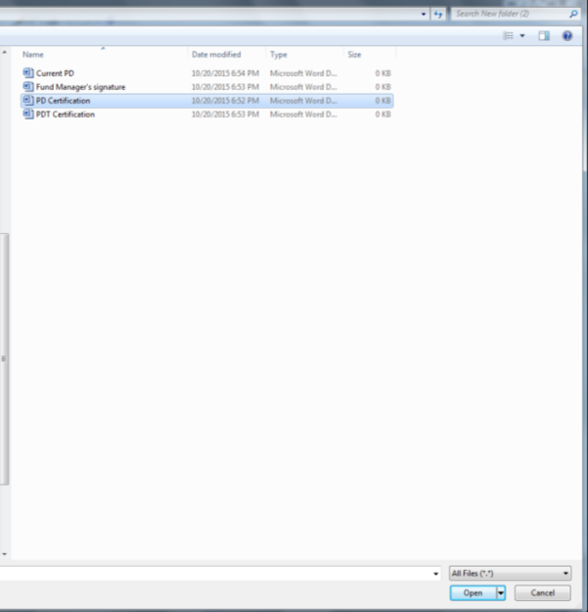
Click <Submit>
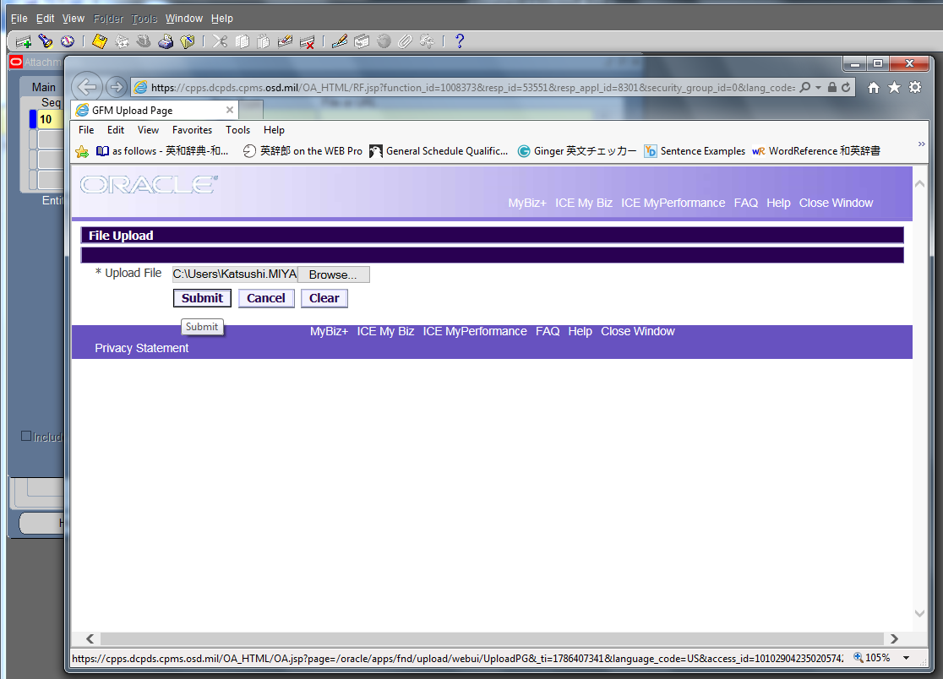

Close the window by hitting X
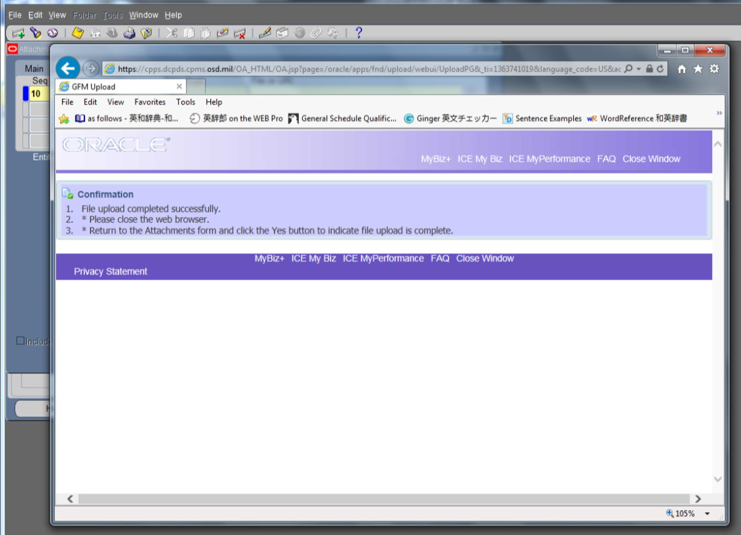
Click <Yes>
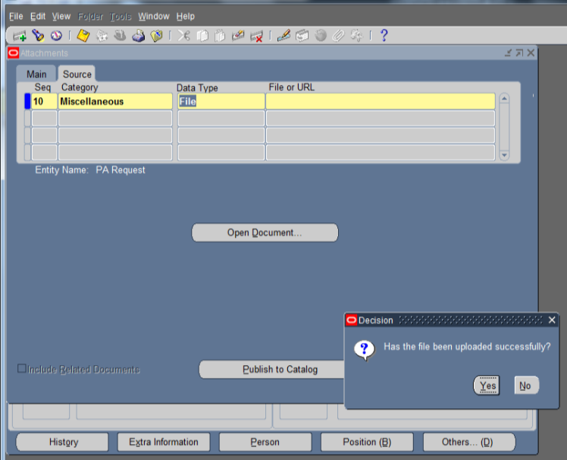

The file is uploaded successfully
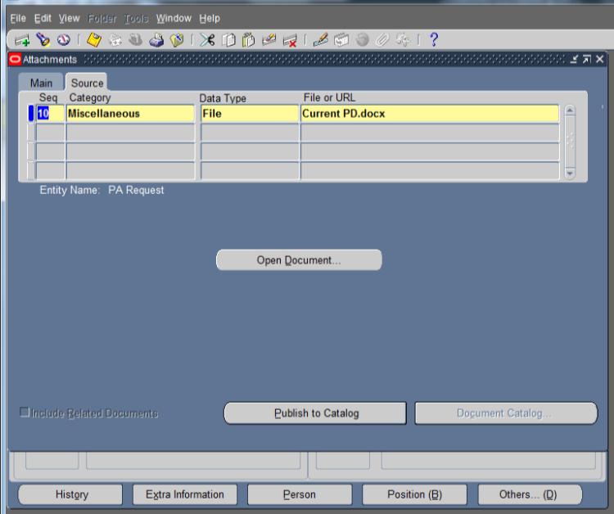
Click <New> for additional files
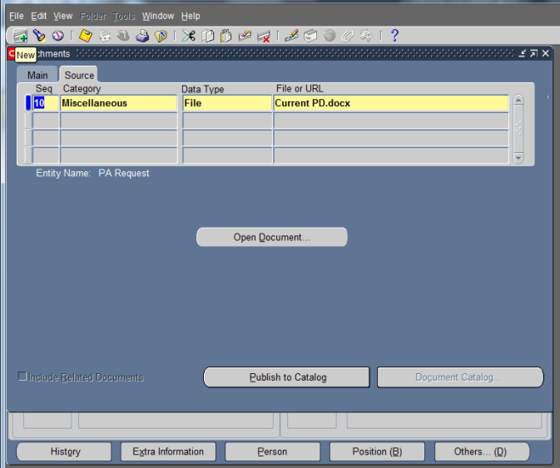

Once uploading is completed, click <Save>
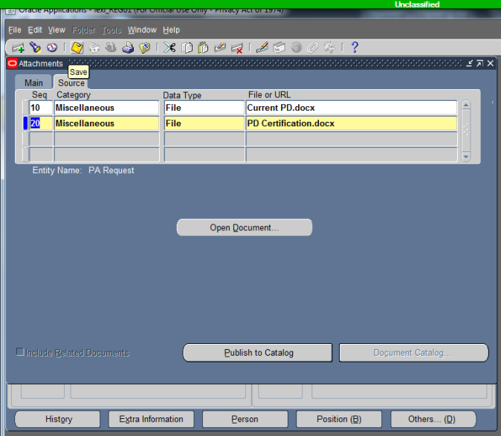

Click <OK>
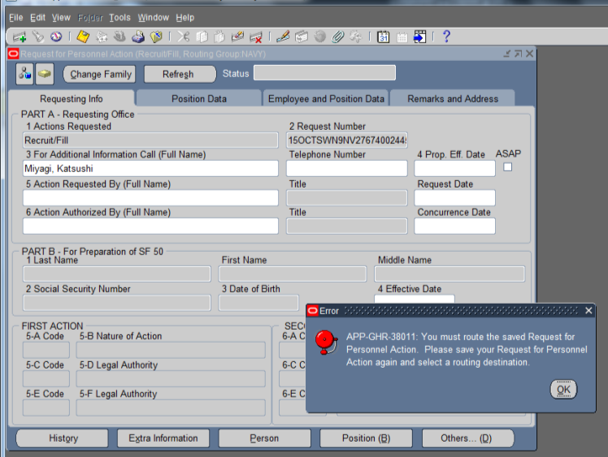

Click <Print>
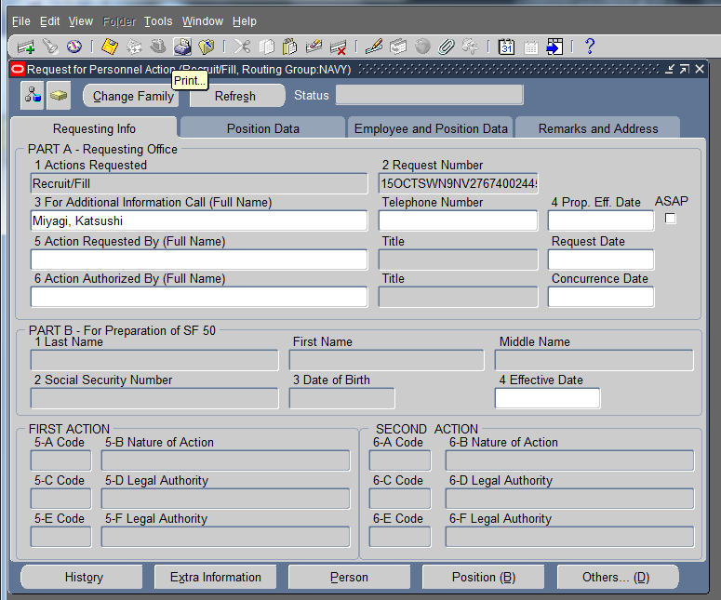
Click <OK>
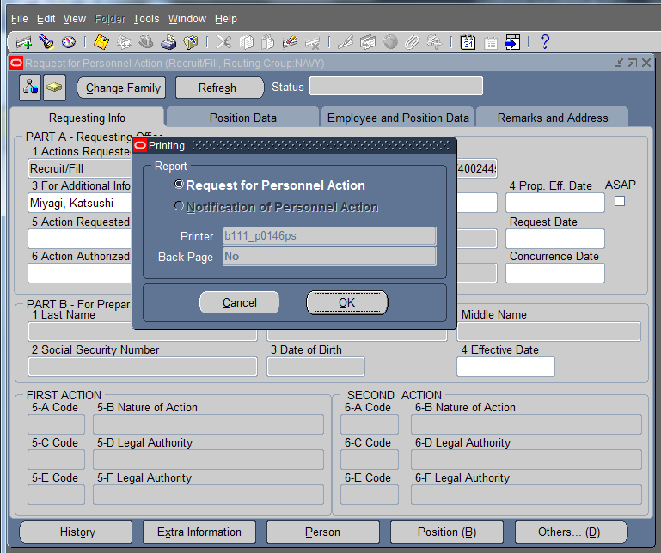

Click <OK>
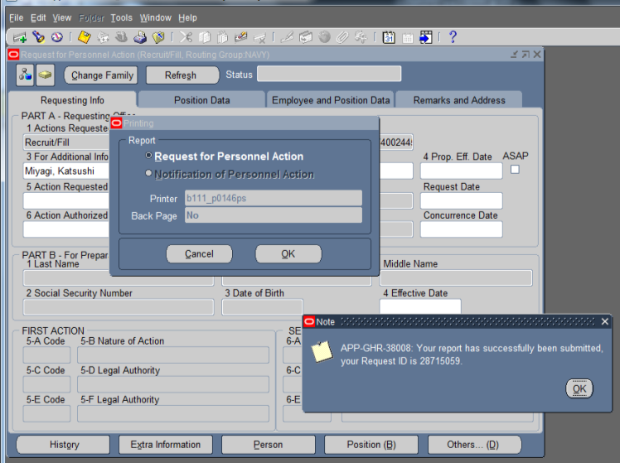

Click <Save>
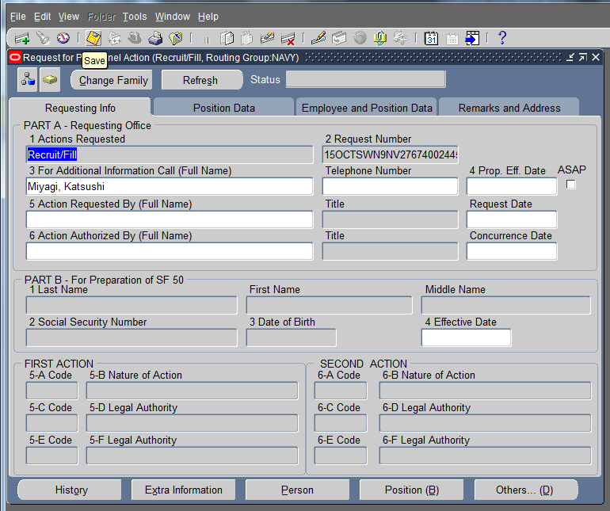

Click <Yes>
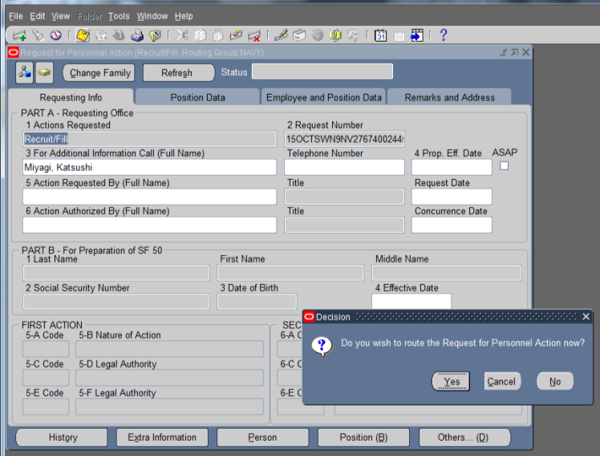
Click <OK>
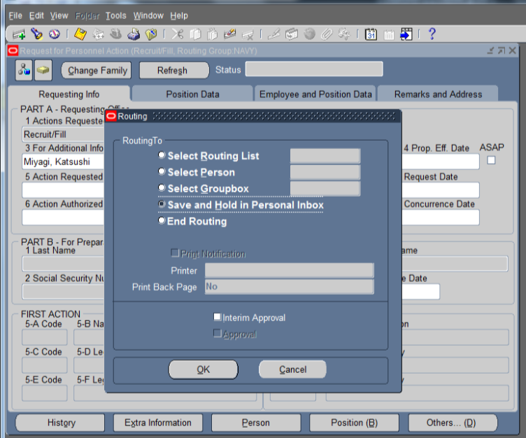

Close window by hitting X
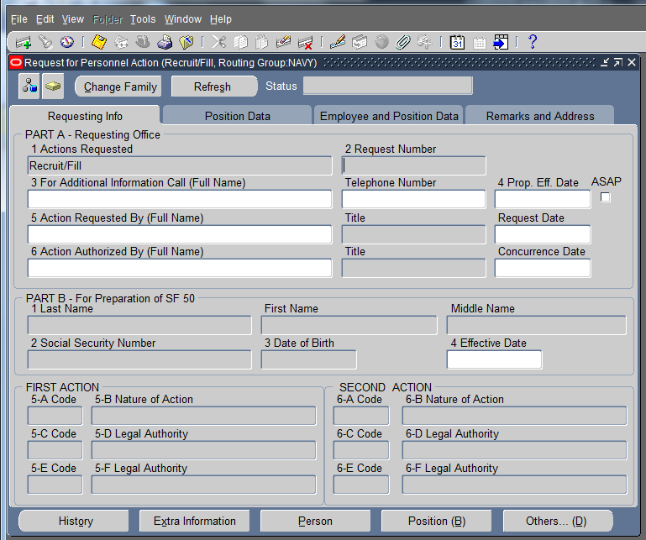
Under the view tab, click <Requests>
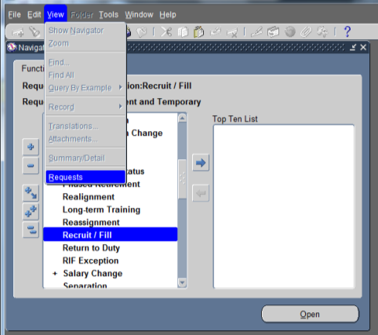

Click <Find>
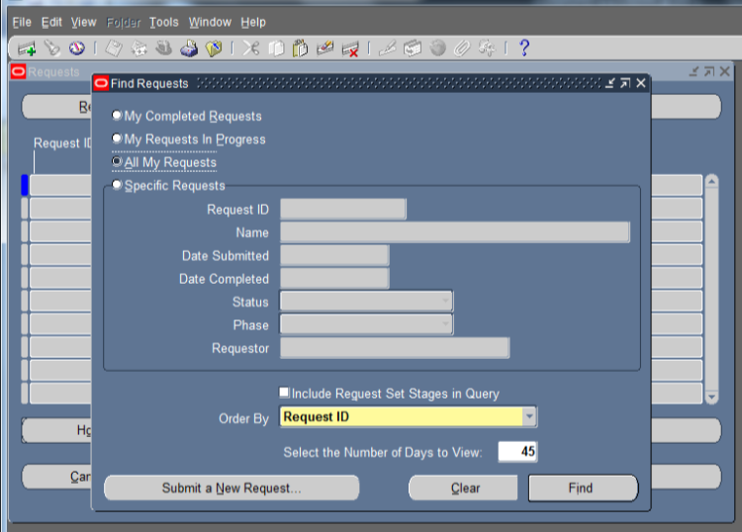
Click <View Output>
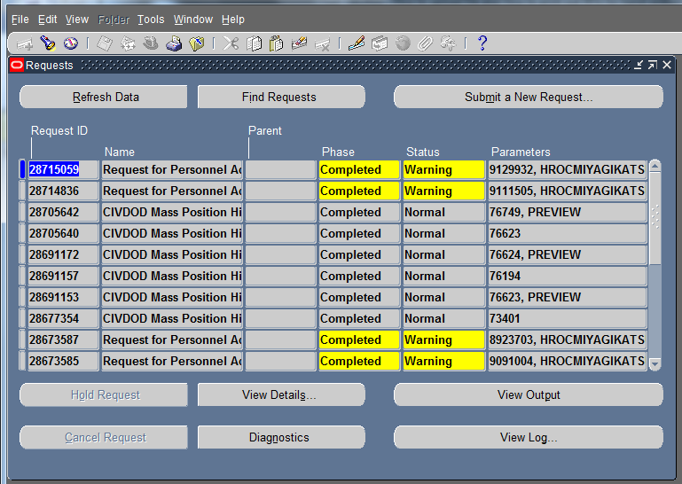

The download prompt appears in other windows
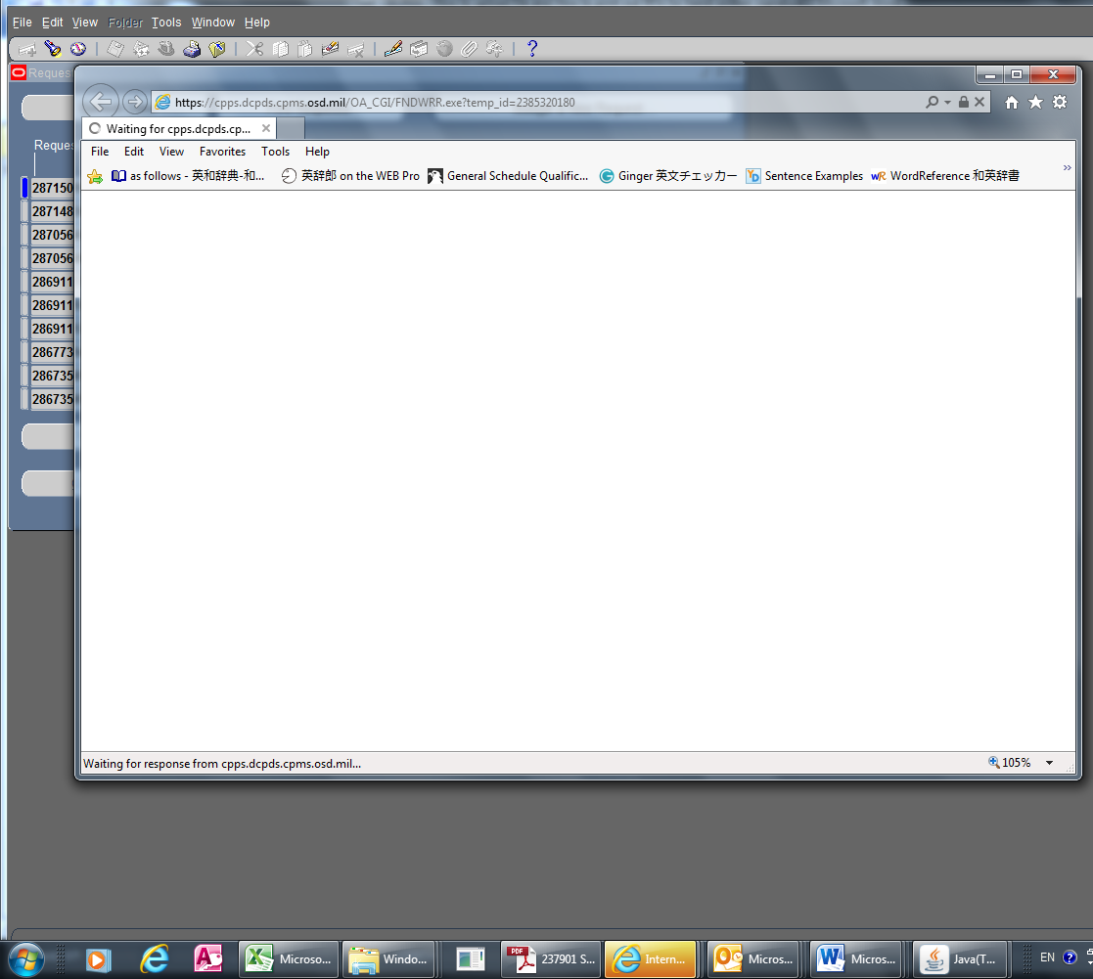
Click <Save As>
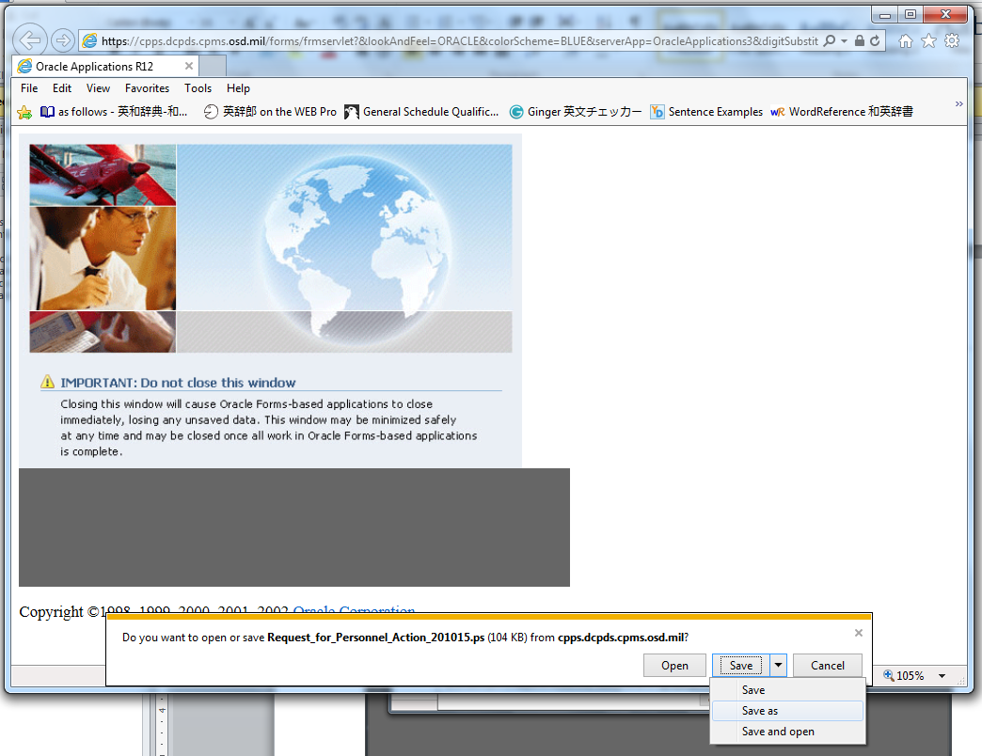

Select Desktop and Save
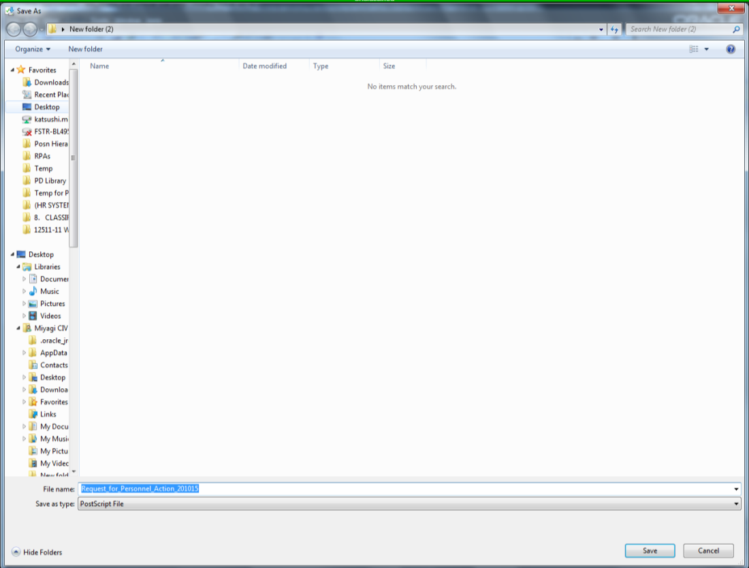
Click <Open>
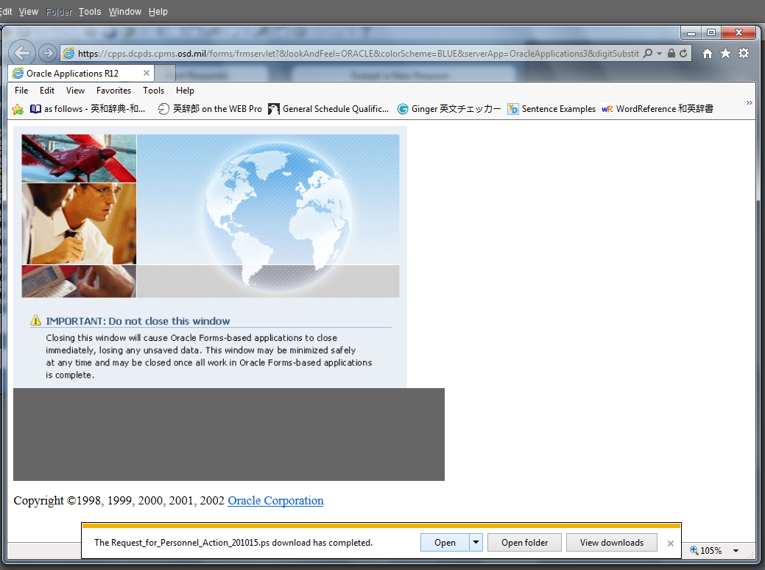

Double click
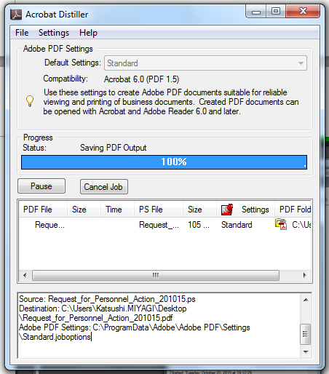
Double click to open
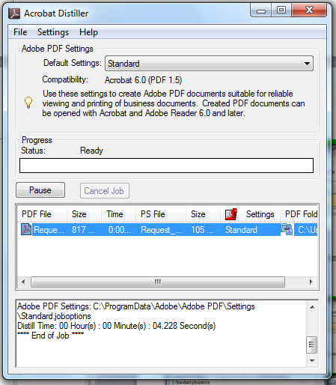

Click “Print”
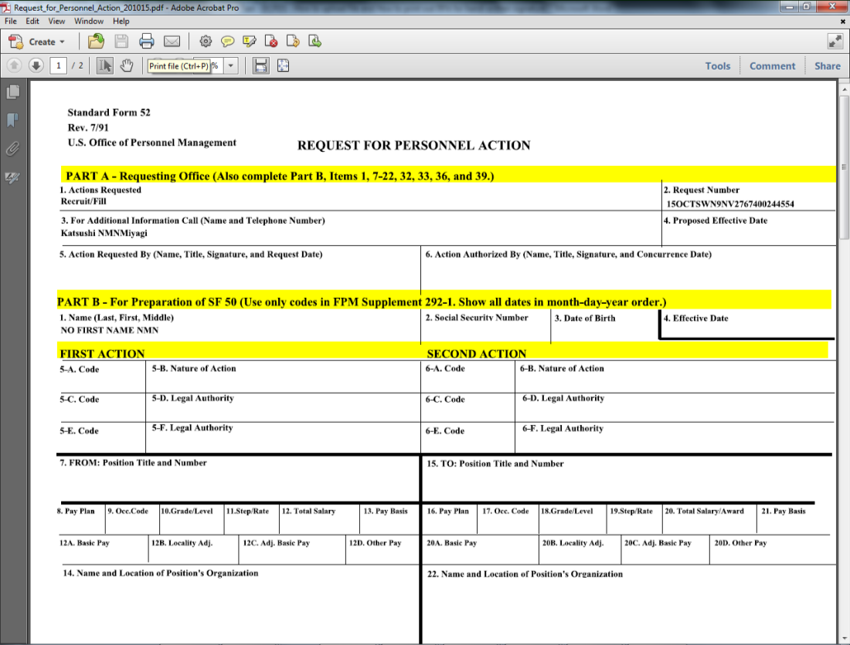
Select <Pages>, type 1,3 and click <Print>
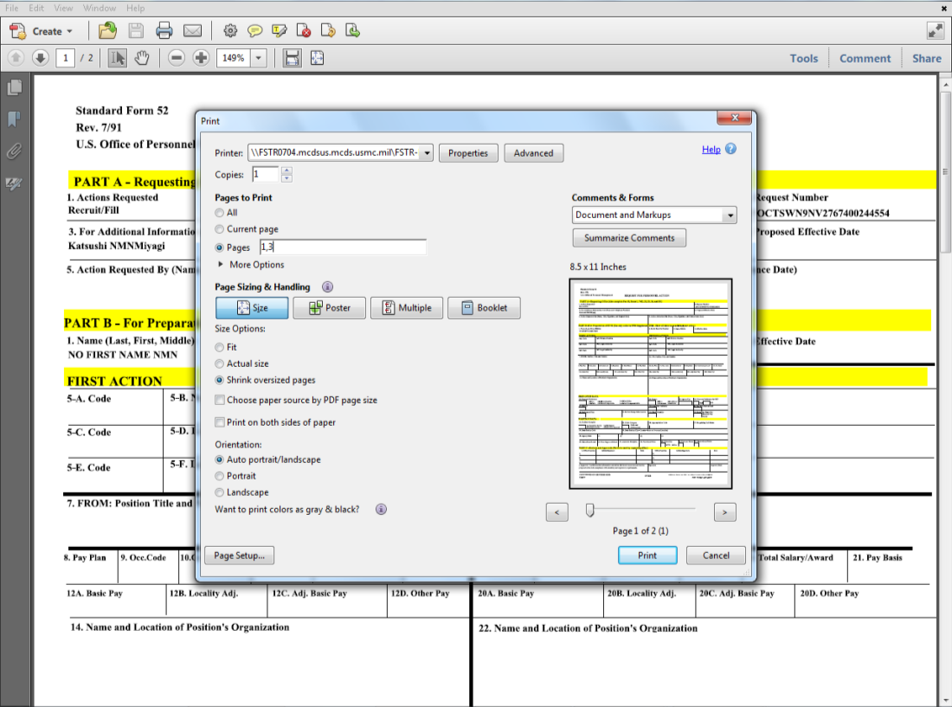

Using typewriter or Adobe software, type name of fund manager and concurrence date. Have a fund manager place his/her signature (digitally or hand-written).
Scan signed copy and save it on the desktop with the name “Signed RPA”.
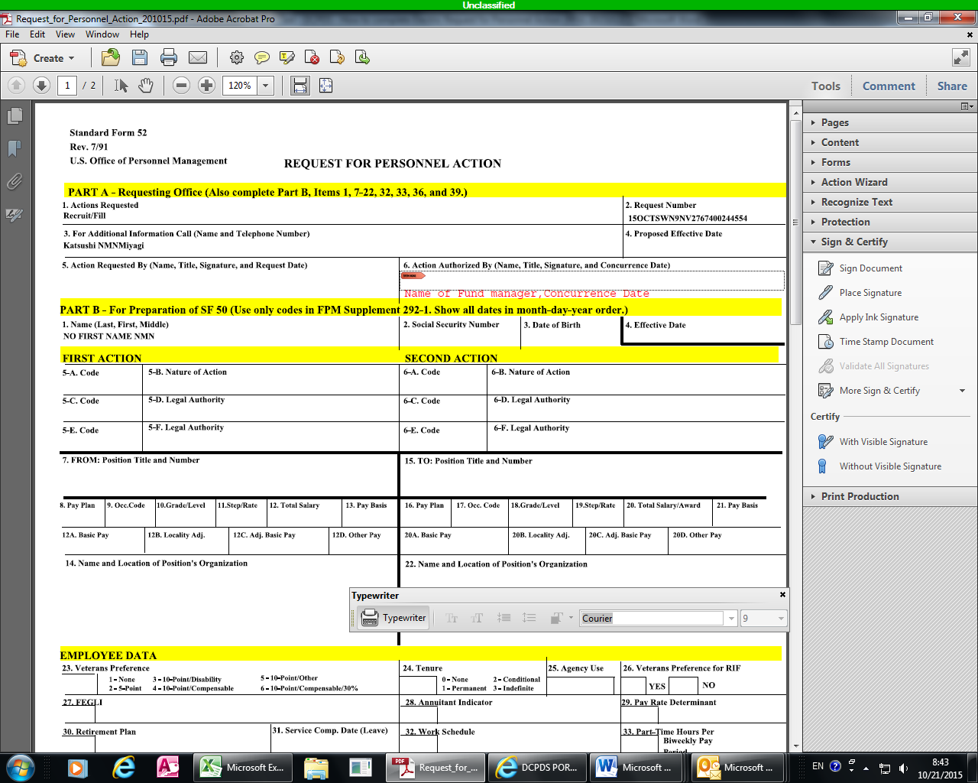
Go back to this screen (Ref: Page 4 – 7) and click civilian inbox
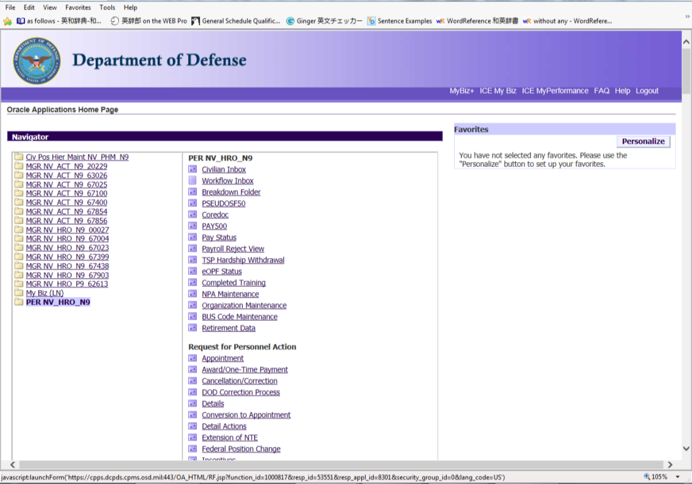

Wait till Java applet finishes running (Do not close this window)
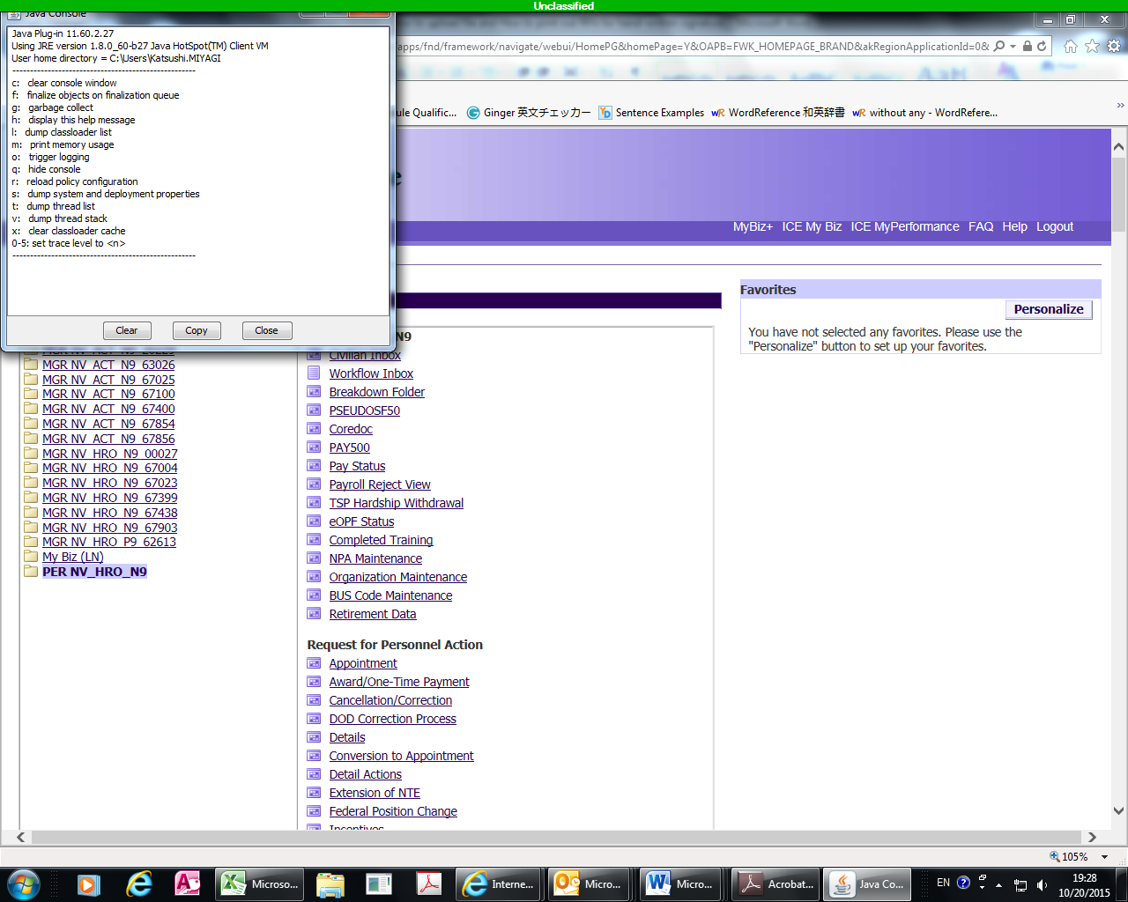
Click <Continue>
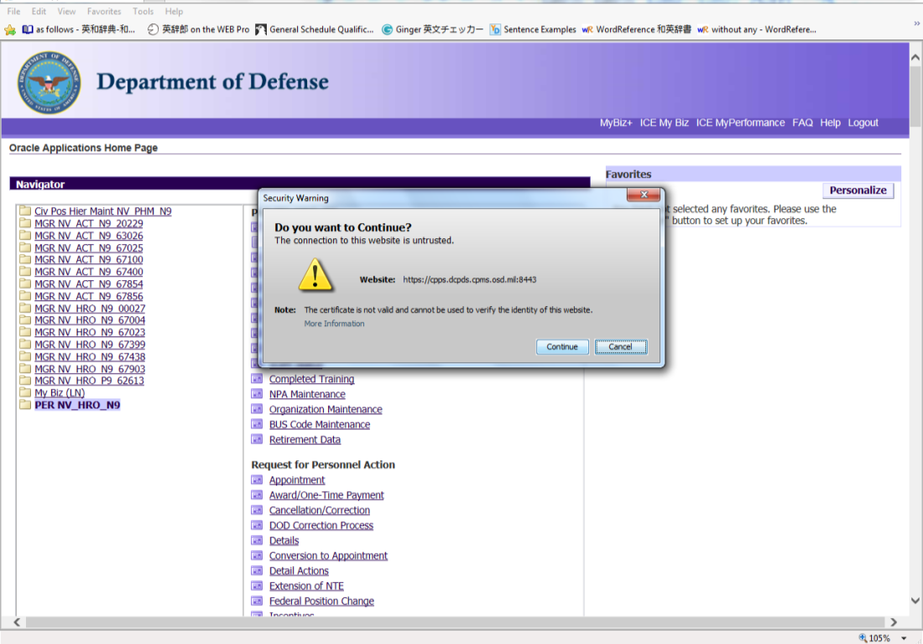

Wait till applet finishes working (Do not close this window)
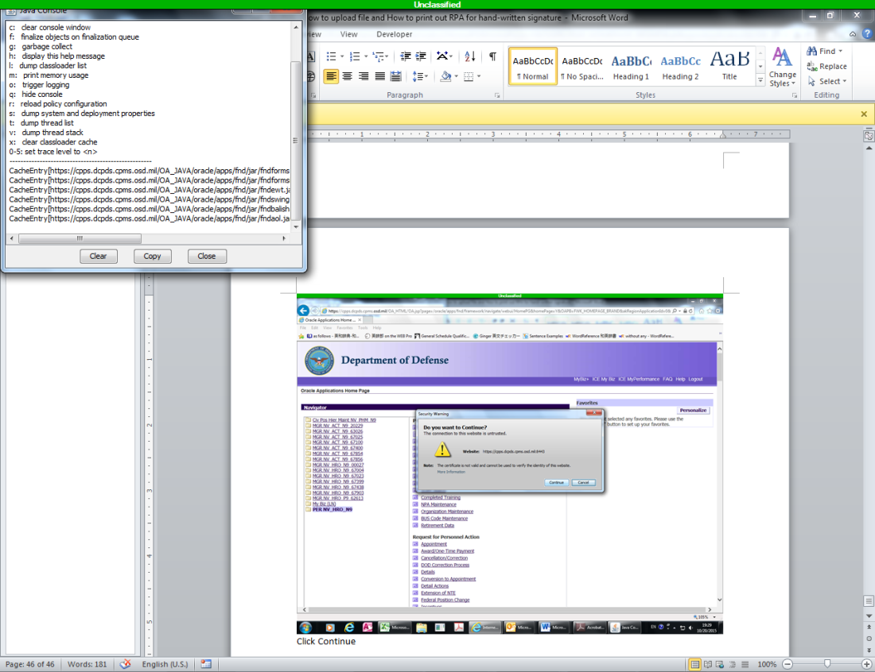
Press <Ctrl Key> + <F11 Key> at the same time.
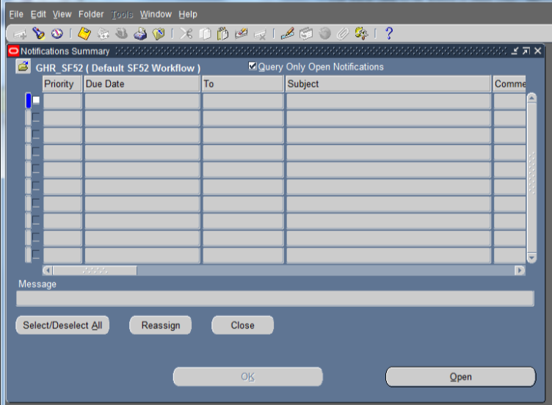

RPAs in your inbox appear. Select the RPA and click <Respond>
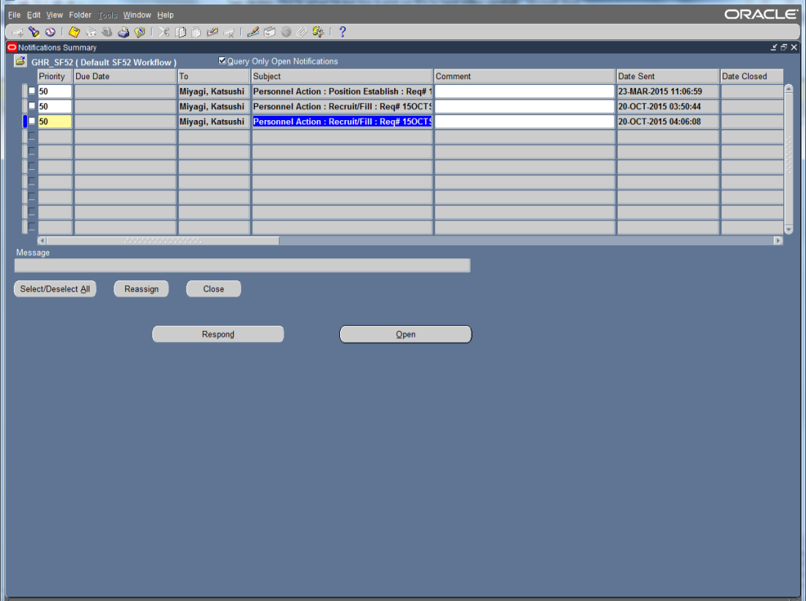
Click <Attachment> and attach the scanned signed RPA
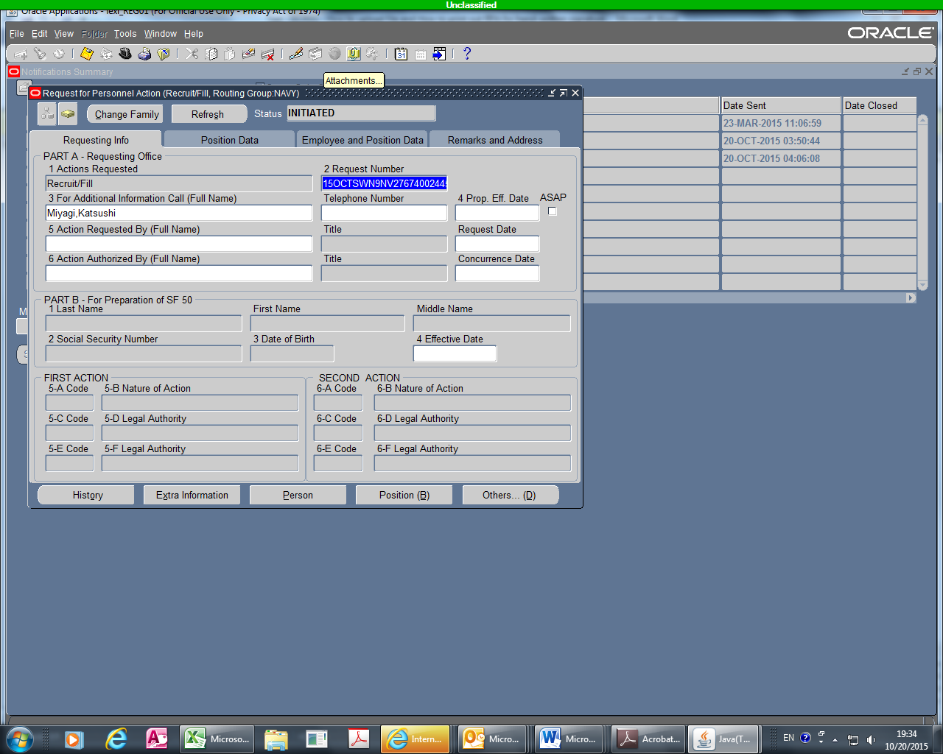

Once uploading is completed, click <Save>.
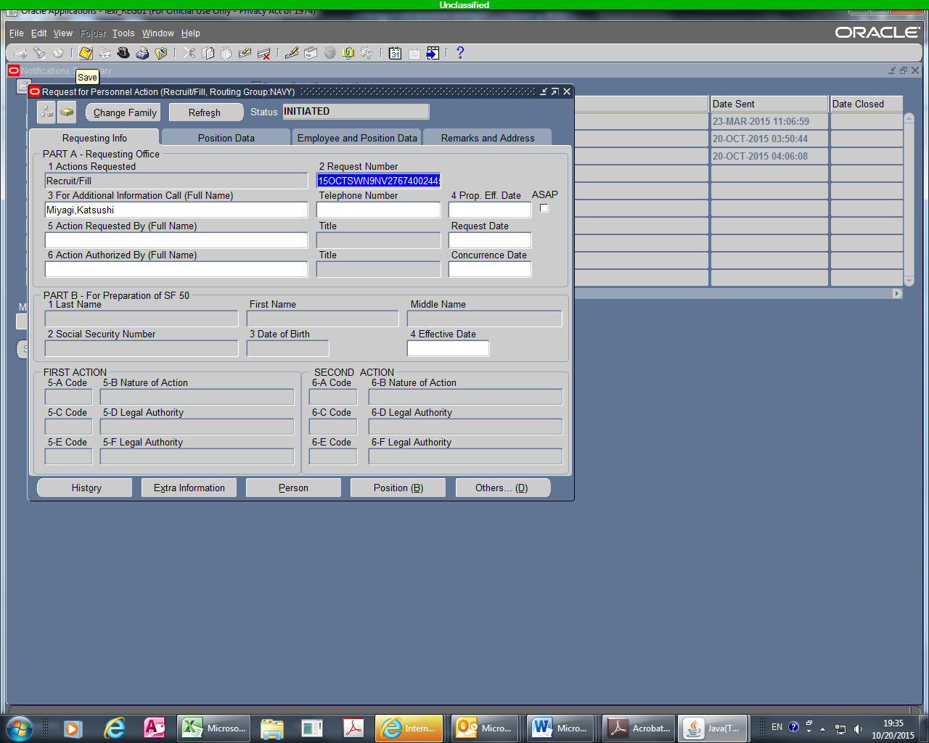
Click <Yes>
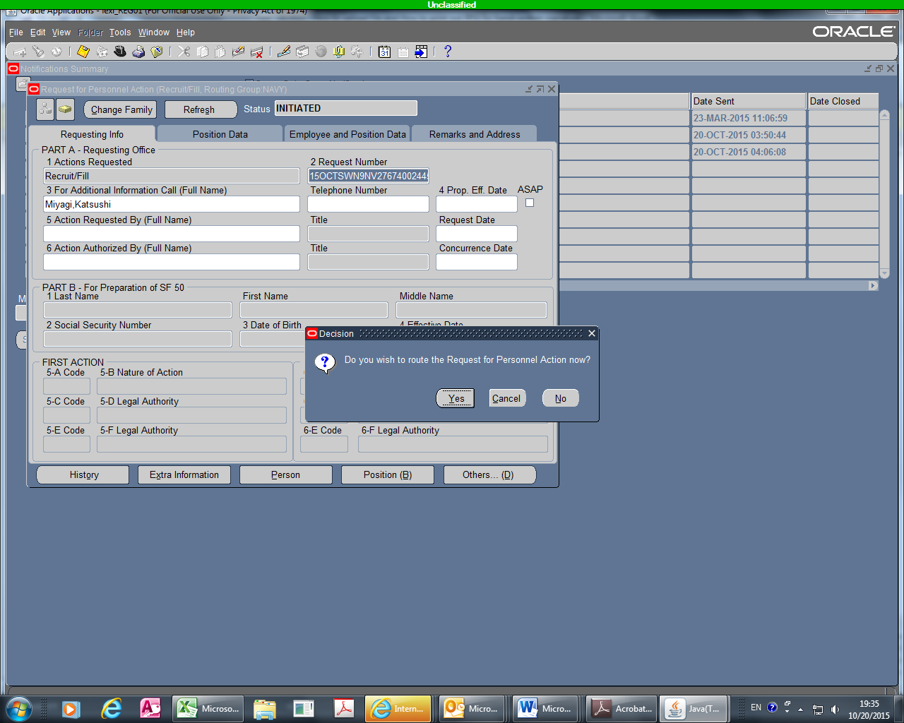

Select <Select Groupbox>
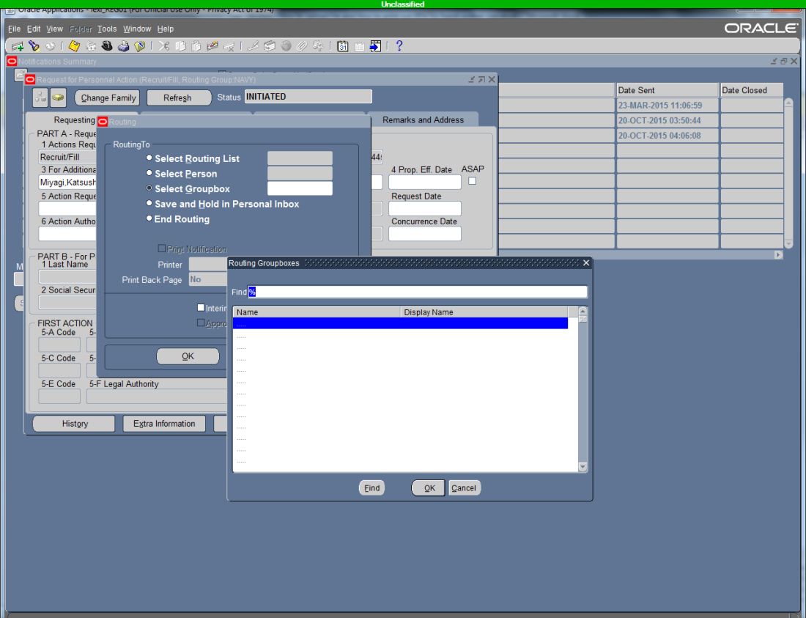
Type “67400” an click <OK>
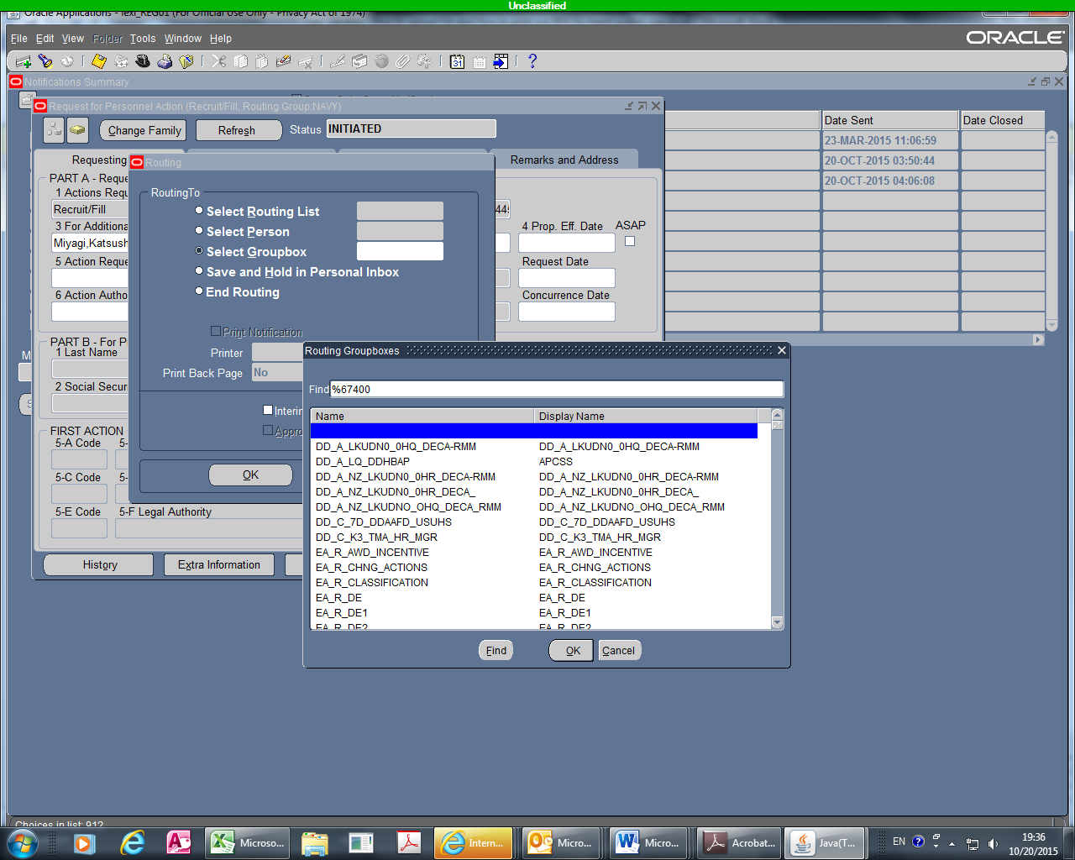

Select top one <NV_A_N9_67400_CD> and click <OK>
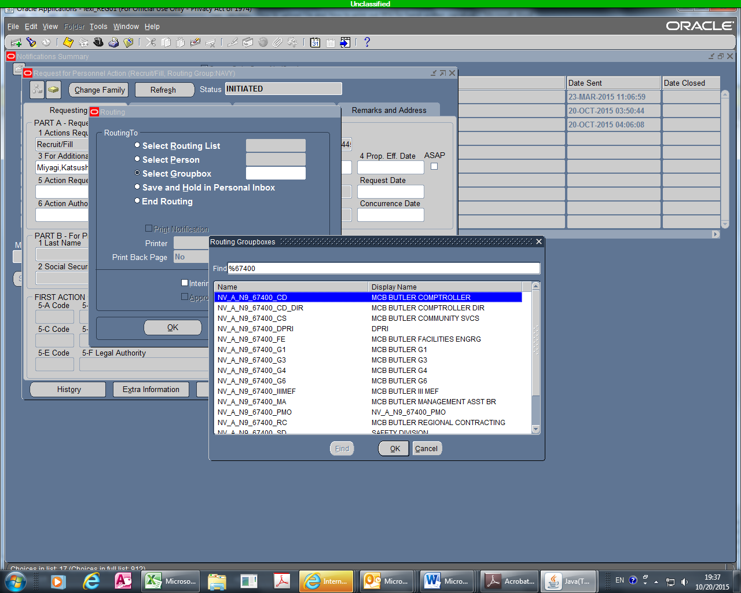
**** COMPLETED**** The RPA was forwarded to G-8 for review.
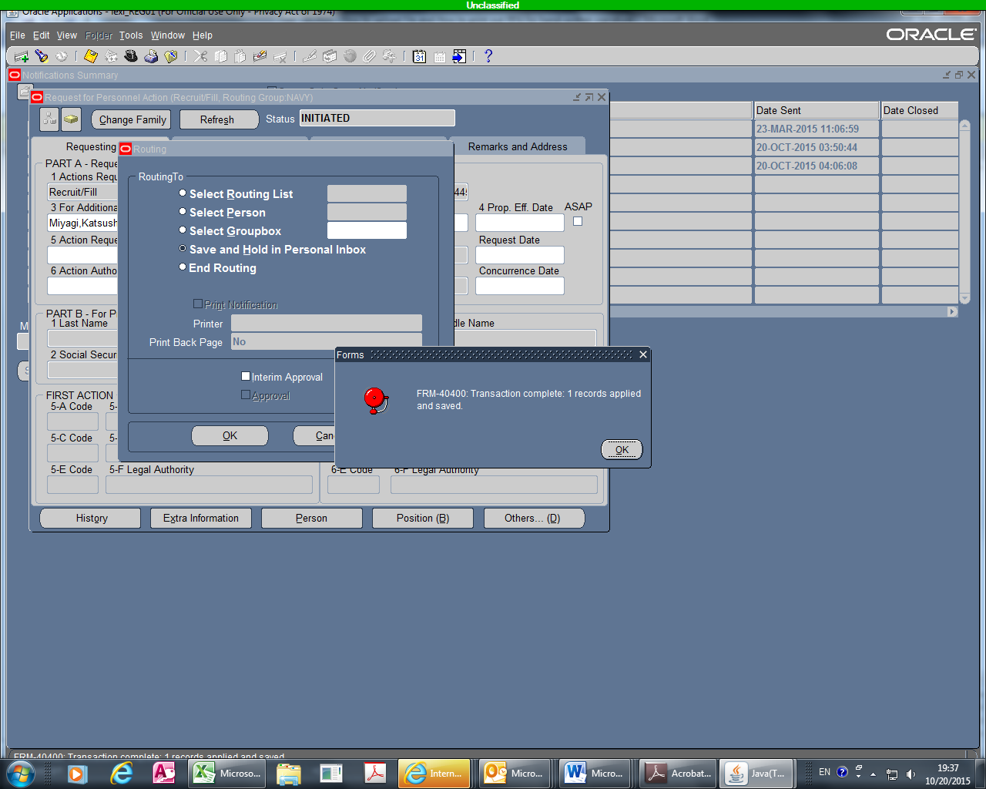

Notify G-8 of RPA number by sending a email to Mr. Richard L. McConkie of G-8 (Comptroller).
